SUPPLEMENTARY MATERIAL
Alternatives for the biomonitoring of fish and phytoplankton in tropical streams

TABLES
Table S1 List of studies using optimization strategies involving fish biomonitoring. The strategies used in the research (NR= Numerical resolution, SG= Surrogate group, TR= Taxonomic resolution), the studied environment and association or not with phytoplankton (Phyto) are shown.
Author/Year | Strategy | Search environment | Phyto
(Kilgour and Barton 1999) | SG | Stream | No
(Paszkowski and Tonn 2000) | SG | Lakes | No
(Paavola et al. 2003) | SG | Stream and River | No
(Bowman et al. 2008) | SG | Lakes | Yes
(Grenouillet et al. 2008) | SG | Stream | Yes
(Larsen et al. 2012) | SG | Stream | No
(Padial et al. 2012) | SG | Floodplain and main river channel | Yes
(Mueller et al. 2013) | TR, NR | Floodplain and rivers | No
(Bae et al. 2014) | SG | Stream | No
(Backus-Freer and Pyron 2015) | SG | Stream | No
(Ribas and Padial 2015) | SG, TR, NR | Floodplain and main river channel | Yes
(Kimmel and Argent 2016) | SG | Stream | No

Table S2 Environmental characterization of streams sampled in the upper Tocantins river basin, sub-basin of the Santa Teresa river, Cerrado biome, Brazil. Data obtained from Barbosa et al. 2019.
Local and landscape environmental variables | Average | Coefficient of variation (%) | Minimum | Maximum
Chlorophyll-a (mg/L) | 1.37 | 45.27 | 0.30 | 2.95
Total nitrogen (mg/L) | 0.41 | 31.82 | 0.12 | 0.71
Total phosphorus (mg/L) | 5.38 | 81.68 | 0.71 | 15.28
Conductivity (μS/cm) | 147.58 | 50.25 | 45.50 | 343
Dissolved oxygen (mg/L) | 5.81 | 16.52 | 4.06 | 7.35
pH | 6.87 | 10.17 | 5.05 | 8.01
Turbidity (NTU) | 28.97 | 74.35 | 10.90 | 88.70
Water temperature (°C) | 25.98 | 8.56 | 22 | 29.20
Flow (rot./s) | 445.62 | 60.43 | 71.56 | 1039.11
Shading (%) | 37.55 | 60.83 | 4.52 | 77.42
Depth | 15.98 | 38.18 | 7.41 | 31.87
Average width | 3.11 | 37.68 | 1.44 | 6.08
Consolidated substrate (%) | 40.46 | 58.21 | 0 | 72.78
Leaf litter substrate (%) | 11.49 | 83.85 | 0 | 42.78
Leaf litter banks (%) | 4.12 | 139.21 | 0 | 26.67
Forest width (m) | 16.02 | 58.11 | 0 | 30
Remaining vegetation in buffer 500 m (%) | 71.55 | 30.77 | 10.52 | 100
Pasture in watershed (%) | 18.08 | 76.04 | 0.40 | 57.77
Pasture in buffer 100 m (%) | 22.17 | 116.02 | 0 | 100
Bare soil in watershed (%) | 0.20 | 140.92 | 0 | 1.32
Bare soil in buffer 500 m (%) | 0.39 | 212.36 | 0 | 3.23
Bare soil in buffer 100 m (%) | 0.17 | 529.15 | 0 | 4.90
Watershed area (km²) | 15.78 | 78 | 0.14 | 49.56
Mean (watershed) slope (%) | 21.18 | 23.95 | 11.37 | 32.17
Altitude (m) | 475.45 | 8.98 | 392 | 562

Table S3 List of fish species captured in the North region of Goiás, Upper Tocantins system, sub-basin of the Santa Teresa river, Cerrado biome, Brazil. Abundance, Occurrence, ecological classification of habitat use in relation the position in water column and trophic category are also presented. See list of abbreviations for their descriptions.
Taxon | Abundance |  | Occur | Ecological classification
 |  |  |  | Habitat use |  |  |  | Trophic category
 | Total | Max |  | Bent | Nect | Nectben | Marg | Detrit | T-Invert | A-Invert | Piscivore | Algivore | Herbivore
CHARACIFORMES
Anostomidae
Leporinus friderici (Bloch, 1794) | 2 | 2 | 1 | 0 | 0 | 1 | 0 | 0 | 22.21 | 0 | 44.43 | 0 | 33.36
Leporinus sp. | 3 | 3 | 1 | 0 | 0 | 1 | 0 | 0 | 0.12 | 62.44 | 0 | 4.49 | 32.94
Characidae
Astyanax elachylepis Bertaco and Lucinda, 2005 | 156 | 31 | 12 | 0 | 1 | 0 | 0 | 0 | 89.12 | 0 | 1.21 | 2.42 | 7.25
Astyanax novae Eigenmann, 1911 | 441 | 55 | 27 | 0 | 1 | 0 | 0 | 0 | 35.53 | 0.65 | 0.73 | 0 | 63.09
Bryconops melanurus (Bloch, 1794) | 35 | 8 | 10 | 0 | 1 | 0 | 0 | 0 | 95.3 | 2.88 | 0 | 0 | 1.82
Creagrutus britskii Vari and Harold, 2001 | 368 | 68 | 21 | 0 | 0 | 1 | 0 | 0 | 3.29 | 93.75 | 0 | 0 | 2.97
Hemigrammus ataktos Marinho, Dagosta and Birindelli, 2014 | 362 | 93 | 19 | 0 | 1 | 0 | 0 | 49.02 | 41.18 | 3.14 | 0 | 4.9 | 1.76
Jupiaba apenina Zanata, 1997 | 16 | 7 | 5 | 0 | 1 | 0 | 0 | 0 | 82.77 | 9.27 | 0 | 0.87 | 7.09
Knodus cf. chapadae (Fowler, 1906) | 3448 | 230 | 29 | 0 | 1 | 0 | 0 | 0 | 92.14 | 5.56 | 0 | 0.46 | 1.83
Moenkhausia oligolepis (Günther, 1864) | 125 | 14 | 22 | 0 | 1 | 0 | 0 | 2.15 | 74.52 | 1.14 | 0 | 0.03 | 22.17
Moenkhausia pankilopteryx Bertaco and Lucinda, 2006 | 11 | 11 | 1 | 0 | 1 | 0 | 0 | 0.58 | 59.02 | 1.47 | 0.15 | 0.07 | 38.72
Phenacogaster sp. | 2 | 2 | 1 | 0 | 1 | 0 | 0 | 0 | 0 | 100 | 0 | 0 | 0
Serrapinnus tocantincinsis Malabarba and Jerep, 2014 | 48 | 48 | 1 | 0 | 1 | 0 | 0 | 0 | 0 | 0 | 0 | 0 | 0
Crenuchidae
Characidium aff. zebra Eigenmann, 1909 | 1353 | 161 | 28 | 0 | 0 | 1 | 0 | 0 | 0 | 99.77 | 0 | 0 | 0.23
Curimatidae
Steindachnerina amazônica (Steindachner, 1911) | 38 | 20 | 8 | 0 | 0 | 1 | 0 | 100 | 0 | 0 | 0 | 0 | 0
Erytrhinidae
Hoplias malabaricus (Bloch, 1794) | 67 | 8 | 20 | 0 | 0 | 0 | 1 | 3.53 | 16.31 | 80.15 | 0 | 0 | 0
Parodontidae
Apareiodon machrisi Travassos, 1957 | 50 | 8 | 18 | 0 | 0 | 1 | 0 | 85.84 | 0 | 0 | 0 | 14.16 | 0
GYMNOTIFORMES
Apteronotidae
Apteronotus camposdapazi de Santana and Lehmann, A 2006 | 16 | 3 | 9 | 0 | 0 | 0 | 1 | 0 | 0 | 100 | 0 | 0 | 0
Gymnotidae
Gymnotus aff. carapo Linnaeus, 1758 | 50 | 7 | 17 | 0 | 0 | 0 | 1 | 9.01 | 0 | 90.99 | 0 | 0 | 0
Sternopygidae
Eigenmannia aff. trilineata López and Castello, 1966 | 3 | 2 | 2 | 0 | 0 | 0 | 1 | 0 | 0 | 2.6 | 0 | 0 | 97.4
Sternopygus macrurus (Bloch and Schneider, 1801) | 19 | 5 | 9 | 0 | 0 | 0 | 1 | 0 | 1.16 | 98.84 | 0 | 0 | 0
PERCIFORMES
Cichlidae
Cichlasoma araguaiense Kullander, 1983 | 40 | 12 | 9 | 0 | 0 | 1 | 0 | 5.06 | 0.1 | 94.84 | 0 | 0 | 0
Crenicichla labrina (Spix and Agassiz, 1831) | 36 | 9 | 12 | 0 | 0 | 1 | 0 | 0 | 0 | 100 | 0 | 0 | 0
Retroculus lapidifer (Castelnau, 1855) | 1 | 1 | 1 | 0 | 0 | 1 | 0 | 0 | 0 | 100 | 0 | 0 | 0
SILURIFORMES
Callichthyidae
Aspidoras albater Nijssen and Isbrücker, 1976 | 179 | 33 | 16 | 1 | 0 | 0 | 0 | 0 | 0 | 100 | 0 | 0 | 0
Cetopsidae
Cetopsis arcana Vari, Ferraris and de Pinna, 2005 | 4 | 2 | 3 | 0 | 0 | 1 | 0 | 0 | 95.47 | 4.36 | 0 | 0.17 | 0
Heptapteridae
Cetopsorhamdia molinae Miles, 1943 | 11 | 5 | 3 | 1 | 0 | 0 | 0 | 0 | 0 | 100 | 0 | 0 | 0
Cetopsorhamdia sp. | 2 | 2 | 1 | 1 | 0 | 0 | 0 | 0 | 0 | 100 | 0 | 0 | 0
Imparfinis cf. borodini Mees and Cala, 1989 | 5 | 3 | 2 | 1 | 0 | 0 | 0 | 5.2 | 0 | 73.88 | 0 | 0 | 20.91
Imparfinis cf. schubarti (Gomes, 1956) | 31 | 12 | 9 | 1 | 0 | 0 | 0 | 0 | 0.54 | 99.46 | 0 | 0 | 0
Phenacorhamdia sp. | 143 | 18 | 27 | 1 | 0 | 0 | 0 | 0 | 1.36 | 98.46 | 0 | 0 | 0.17
Pimelodella sp. | 42 | 23 | 4 | 0 | 0 | 1 | 0 | 0 | 100 | 0 | 0 | 0 | 0
Rhamdia aff. quelen (Quoy and Gaimard, 1824) | 24 | 5 | 11 | 0 | 0 | 1 | 0 | 0 | 35.29 | 17.65 | 47.06 | 0 | 0
Rhamdia cf. itacaiunas Silfvergrip, 1996 | 4 | 2 | 3 | 0 | 0 | 1 | 0 | 0 | 99.29 | 0 | 0 | 0 | 0.71
Loricariidae
Ancistrus cf. aguaboensis Fisch-Muller, Mazzoni and Weber, 2001 | 149 | 42 | 7 | 1 | 0 | 0 | 0 | 100 | 0 | 0 | 0 | 0 | 0
Ancistrus cf. minutus Fisch-Muller, Mazzoni and Weber, 2001 | 309 | 32 | 27 | 1 | 0 | 0 | 0 | 100 | 0 | 0 | 0 | 0 | 0
Farlowella cf. oxyrryncha (Kner, 1853) | 5 | 5 | 1 | 0 | 0 | 0 | 1 | 100 | 0 | 0 | 0 | 0 | 0
Harttia punctata Rapp Py-Daniel and Oliveira, 2001 | 276 | 44 | 18 | 1 | 0 | 0 | 0 | 100 | 0 | 0 | 0 | 0 | 0
Hemiancistrus cerrado de Souza, Melo, Chamon and Armbruster, 2008 | 7 | 7 | 1 | 1 | 0 | 0 | 0 | 99.87 | 0 | 0.04 | 0 | 0.09 | 0
Hypostomus sp.1 | 285 | 48 | 21 | 1 | 0 | 0 | 0 | 99.06 | 0 | 0 | 0 | 0.94 | 0
Hypostomus cf. ericae Hollanda Carvalho and Weber, 2005 | 116 | 22 | 23 | 1 | 0 | 0 | 0 | 99.67 | 0 | 0 | 0 | 0.33 | 0
Loricaria sp. | 15 | 9 | 4 | 1 | 0 | 0 | 0 | 50.78 | 0 | 49.22 | 0 | 0 | 0
Nannoplecostomus eleonorae Ribeiro, Lima and Pereira, 2012 | 80 | 59 | 2 | 1 | 0 | 0 | 0 | 84.51 | 0 | 0 | 0 | 15.49 | 0
Rineloricaria lanceolata (Günther, 1868) | 23 | 5 | 11 | 1 | 0 | 0 | 0 | 91.59 | 0 | 8.41 | 0 | 0 | 0
Spatuloricaria cf. evansii (Boulenger, 1892) | 49 | 11 | 9 | 1 | 0 | 0 | 0 | 49.15 | 11.3 | 39.55 | 0 | 0 | 0
Trichomycteridae
Ituglanis goya Datovo, Aquino and Langeani, 2016 | 1 | 1 | 1 | 1 | 0 | 0 | 0 | 0 | 13.59 | 81.52 | 0 | 0 | 4.89
SYNBRANCHIFORMES
Synbranchidae
Synbranchus cf. marmoratus Bloch, 1795 | 11 | 11 | 1 | 0 | 0 | 0 | 1 | 76.42 | 0 | 23.58 | 0 | 0 | 0

FIGURES
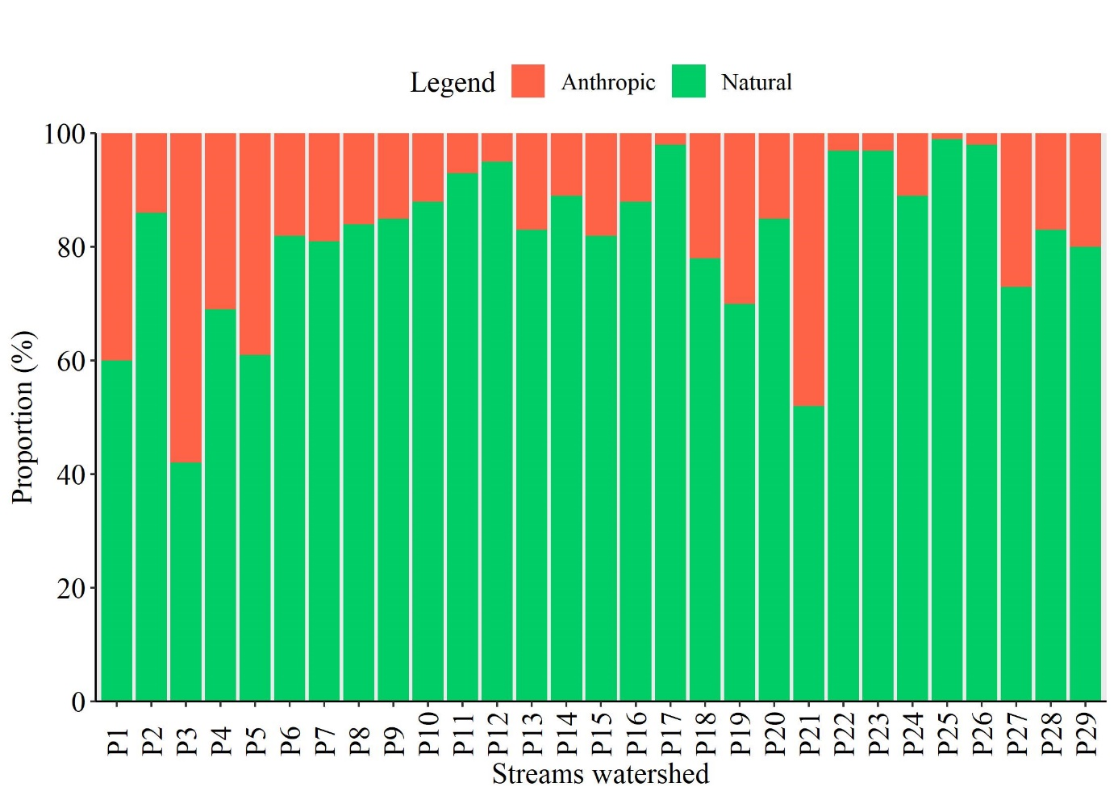
Fig. S1 Percentage of land use anthropic and land natural cover in 29 streams watershed of the sub-basin of the Santa Teresa river, Cerrado biome, Brazil. Data obtained from Barbosa et al. 2019.

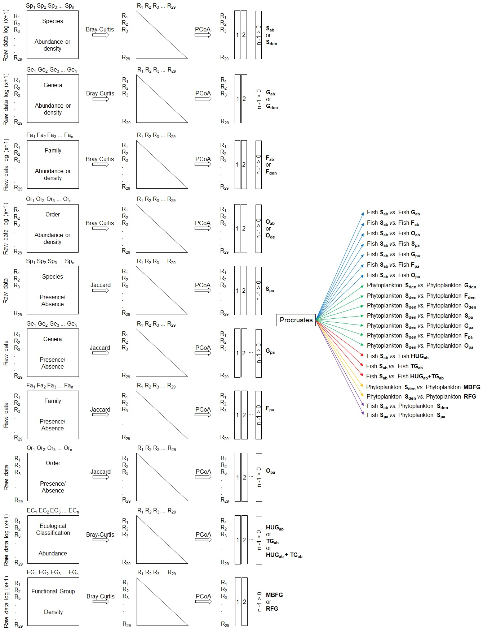
Fig. S2 Schematic representation of taxonomic and numerical resolution (see blue arrows for fish and green for phytoplankton), ecological substitute group (see red arrows for fish and yellow for phytoplankton), and surrogate group (see purple arrows). See list of abbreviations for their descriptions.

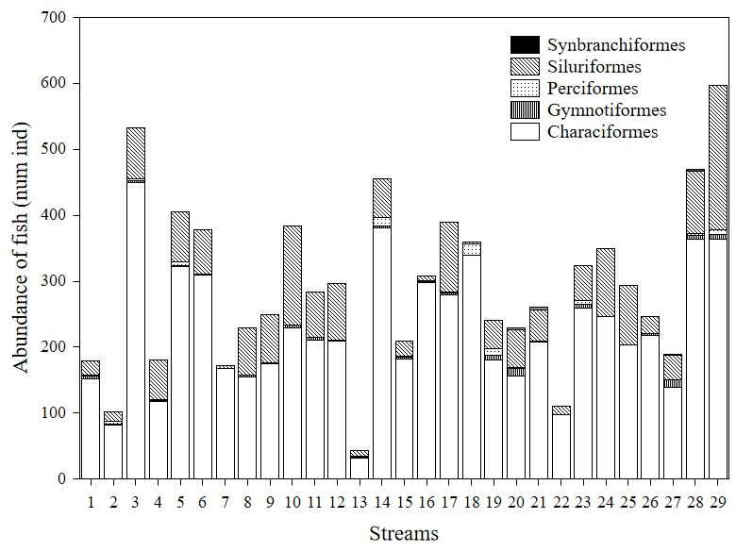
Fig. S3 Abundance of fish (number of individuals) found in 29 streams of Upper Tocantins river basin, sub-basin of the Santa Teresa river, Cerrado biome, Brazil, distributed in five orders.
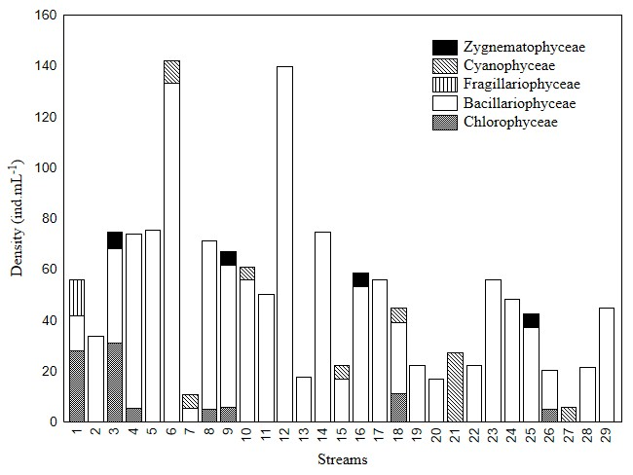
Fig. S4 Density of phytoplankton (individuals.mL⁻¹) by taxonomic class found in 29 streams of Upper Tocantins river basin, sub-basin of the Santa Teresa river, Cerrado biome, Brazil.
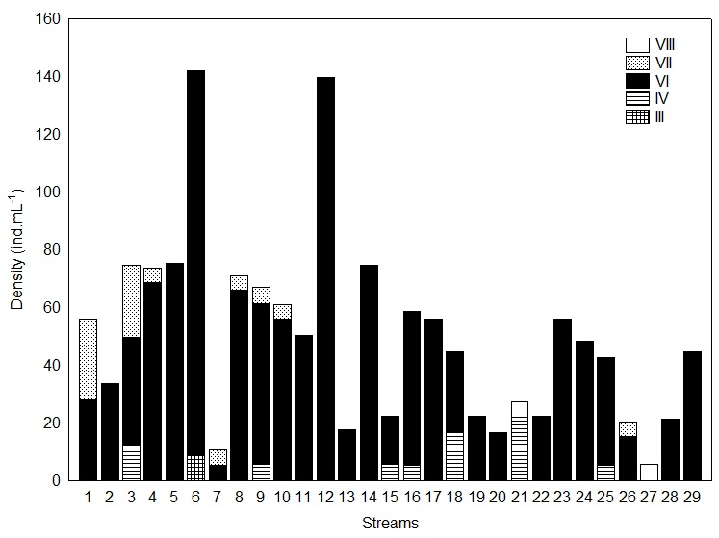
Fig. S5 Density of phytoplankton (individuals.mL⁻¹) by Morphology-Based Functional Groups found in 29 streams of Upper Tocantins river basin, sub-basin of the Santa Teresa river, Cerrado biome, Brazil.
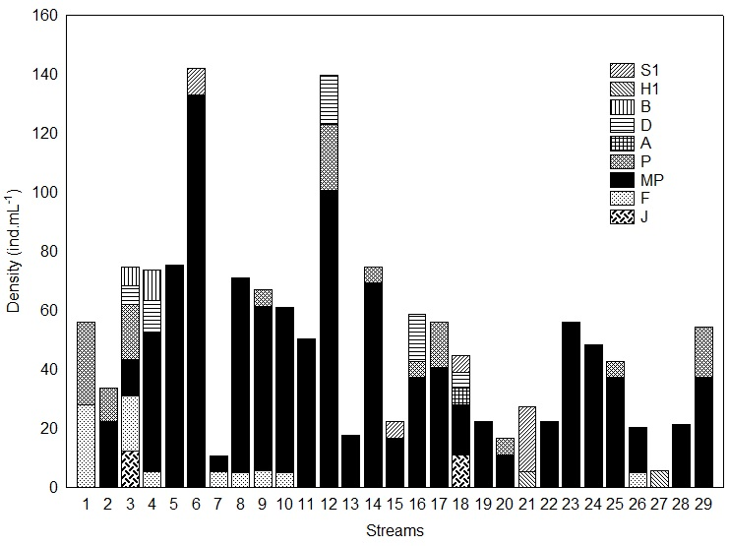
Fig. S6 Density of phytoplankton (individuals.mL⁻¹) by Reynolds Functional Groups found in 29 streams of Upper Tocantins river basin, sub-basin of the Santa Teresa river, Cerrado biome, Brazil.
List of abbreviations
Abbreviation | Description
Table S3
A-Invert | aquatic invertivore
bent | benthic
Detrit | detritivore
marg | marginal
nect | nektonic
nectben | nektobenthic
Occur | occurrence
T-Invert | terrestrial invertivore
Figure S2
EC | ecological classifications
Fa | family
Fab | axes of PCoA with abundance data of family
Fden | axes of PCoA with density data of family
FG | functional group
Fpa | axes of PCoA with family presence/absence data
Gab | axes of PCoA related to data on abundance of genus
Gden | axes of PCoA related to data of density of genus
Ge | genus
Gpa | axes of PCoA related to genus presence/absence data
HUGab | the axes of PCoA with abundance data of habitat use guilds
HUGab+TGab | axes of PCoA with abundance data of habitat use guilds in conjunction with trophic guilds
MBFG | axes of PCoA with density data of phytoplankton Morphology-Based functional groups
n | number of sites sampled
Oab | axes of PCoA with abundance data of orders
Oden | axes of PCoA with order density data
Opa | axes of PCoA with order presence/absence data
Or | order
R | streams sampled
RFG | axes of PCoA with density data of phytoplankton Reynolds Functional Groups
Sab | axes of PCoA with abundance data of species
Sden | axes of PCoA with species density data
Sp | species
Spa | axes of PCoA with species presence/absence data
TGab | axes of PCoA with abundance data of trophic guilds

References
Backus-Freer J, Pyron M (2015) Concordance among fish and macroinvertebrate assemblages in streams of Indiana, USA. Hydrobiologia 758 (1): 141-150. http://dx.doi.org/10.1007/s10750-015-2281-6
Bae M-J, Li F, Kwon Y-S, Chung N, Choi H, Hwang S-J, Park Y-S (2014) Concordance of diatom, macroinvertebrate and fish assemblages in streams at nested spatial scales: implications for ecological integrity. Ecological Indicators 47: 89-101. http://dx.doi.org/10.1016/j.ecolind.2014.07.030
Barbosa HO, Borges PP, Dala-Corte RB, Martins PTA, Teresa FB (2019) Relative importance of local and landscape variables on fish assemblages in streams of Brazilian savanna. Fisheries Management and Ecology 26 (2): 1–12. https://doi.org/10.1111/fme.12331
Bowman MF, Ingram R, Reid RA, Somers KM, Yan ND, Paterson AM, Morgan GE, Gunn JM (2008) Temporal and spatial concordance in community composition of phytoplankton, zooplankton, macroinvertebrate, crayfish, and fish on the Precambrian Shield. Canadian Journal of Fisheries and Aquatic Sciences 65 (5): 919-932. http://dx.doi.org/10.1139/f08-034
Grenouillet G, Brosse S, Tudesque L, Lek S, Baraillé Y, Loot G (2008) Concordance among stream assemblages and spatial autocorrelation along a fragmented gradient. Diversity and Distributions 14 (4): 592-603. https://www.jstor.org/stable/20172013
Kilgour BW, Barton DR (1999) Associations between stream fish and benthos across environmental gradients in southern Ontario, Canada. Freshwater biology 41 (3): 553-566. http://dx.doi.org/10.1046/j.1365-2427.1999.00402.x
Kimmel WG, Argent DG (2016) Community concordance between fishes and benthic macroinvertebrates among adventitious and ordinate tributaries of a major river system. Ecological Indicators 70: 15-22. https://doi.org/10.1016/j.ecolind.2016.05.037
Larsen S, Mancini L, Pace G, Scalici M, Tancioni L (2012) Weak concordance between fish and macroinvertebrates in Mediterranean streams. PLoS One 7 (12): e51115. https://doi.org/10.1371/journal.pone.0051115
Mueller M, Pander J, Geist J (2013) Taxonomic sufficiency in freshwater ecosystems: effects of taxonomic resolution, functional traits, and data transformation. Freshwater Science 32 (3): 762-778. https://doi.org/10.1899/12-212.1
Paavola R, Muotka T, Virtanen R, Heino J, Kreivi P (2003) Are biological classifications of headwater streams concordant across multiple taxonomic groups? Freshwater biology 48 (10): 1912–1923. https://doi.org/10.1046/j.1365-2427.2003.01131.x
Padial AA, Declerck SAJ, Meester L, Bonecker CC, Lansac-Tôha FA, Rodrigues LC, Takeda A, Train S, Velho LFM, Bini LM (2012) Evidence against the use of surrogates for biomonitoring of neotropical floodplains. Freshwater biology 57 (11): 2411-2423. https://doi.org/10.1111/fwb.12008
Paszkowski, CA, Tonn WM (2000) Community concordance between the fish and aquatic birds of lakes in northern Alberta, Canada: the relative importance of environmental and biotic factors. Freshwater biology 43 (3): 421-437. https://doi.org/10.1046/j.1365-2427.2000.00512.x
Ribas LGS, Padial, AA (2016) Erratum to: The use of coarser data is an effective strategy for biological assessments. Hydrobiologia 779 (1): 259-259. https://doi:10.1007/s10750-016-2876-6

